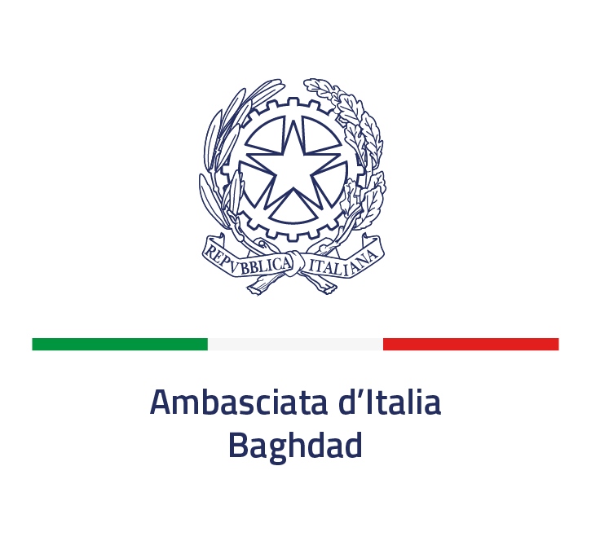

INFORMATION ON THE PROTECTION OF NATURAL PERSONS
WITH REGARD TO THE PROCESSING OF PERSONAL DATA
Regulation (EU) 2016/679, art. 13

The processing of personal data is based on the principles of lawfulness, fairness and transparency to protect the fundamental rights and freedoms of individuals. To this end, the following information is provided:
The data controller is the Ministry of Foreign Affairs and International Cooperation (MAECI) of the Italian Republic, which, in this specific case, operates through the Embassy of Italy in Baghdad, located FOB Fernandez (Tigris Compound) -West Wing - Villa No. 9 e-mail: ambasciata.baghdad@esteri.it
MAECI is provided with a data protection officer who, in case of questions or complaints, can be contacted at the following addresses (Ministry of Foreign Affairs and International Cooperation, Piazzale della Farnesina 1, 00135 ROME, tel. 0039 06 36911 (switchboard), e-mail: rpd@esteri.it; pec: rpd@cert.esteri.it.

- The personal data requested is necessary for the selection of the Sponsor to whom the sponsorship will be entrusted.
- Providing the data is an obligation under Italian law and any refusal to provide the requested data will result in exclusion from the selection procedure or sponsorship.
- The processing will be carried out in manual or computerized mode by specially appointed personnel.
- The data will be communicated to MAECI's internal and external control bodies. By signing this information notice, the interested party gives his or her consent to the communication of the aforementioned data also to the competent local authorities for their verification and to the publication of the essential elements of the contract stipulated on the client's website in accordance with the Italian regulations on the transparency of public contracts.
- Data are retained for a maximum period of 5 years from the time the contractual relationship ends due to completion of performance or other reason, including termination for default. This period is suspended in case of initiation of legal proceedings.
- The data subject may request access to and rectification of his or her personal data. In these cases, the interested party should submit a special request to the contact details indicated in point 1, informing for information the MAECI Data Protection Officer at the contact details indicated in point 2.
- If he/she believes that his/her rights have been violated, the data subject may file a complaint with the MAECI Data Protection Officer. Alternatively, he/she may contact the Data Protection Officer (Piazza di Monte Citorio 121, 00186 Rome, tel. 0039 06 696771 (switchboard), e-mail: garante@gpdp.it, pec: protocollo@pec.gpdp.it) or the judicial authority.

Place and date For acknowledgement and acceptance
The Legal Representative

