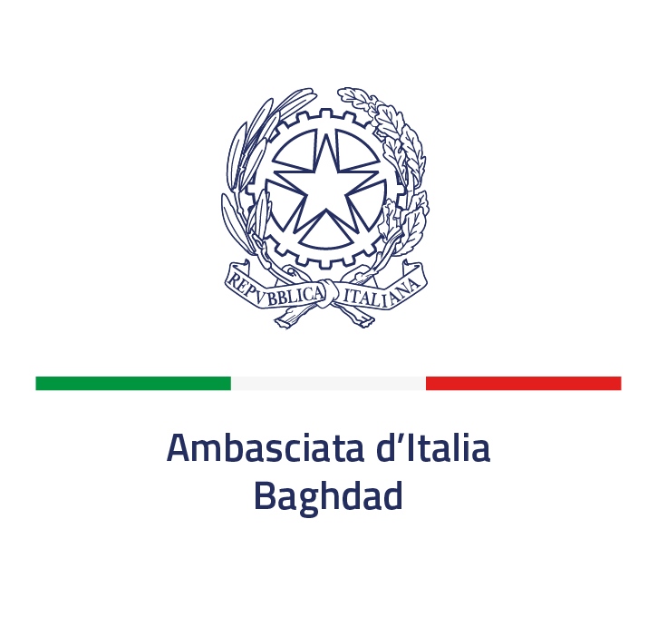

Sponsorship contract
for the June 2 National Day celebrations and
for the events within the framework of the
Integrated Promotion Program 2024 of the Embassy of Italy in Baghdad

HAVING REGARD to the public notice regarding the sponsorship selection procedure for the Integrated Promotion Program 2024 of the Embassy of Italy in Baghdad published on January 31st 2024 on the official website of the Embassy;
HAVING REGARD to the offer, received on ................ from the Company ......................................................... for the award of the appellation of ".............. Sponsor" (please, indicate among the following options: Platinum, Gold, Silver) of the events related to the 2024 Integrated Promotion Program of the Embassy of Italy in Iraq committing to pay a monetary consideration of ........... euros;
HAVING NOTED the compliance of said offer with the aforementioned public notice and the appropriateness of the monetary consideration for which the Sponsor has undertaken to bear, as well as the suitability and reliability of the Company itself;
HAVING REGARD to the decree awarding the selection procedure for the sponsorship of events related to the 2024 Integrated Promotion Program of the Embassy of Italy No. .../2024 in favor of the Company ...........................;
The Embassy of Italy (hereinafter Sponsee), represented by Ambassador Maurizio Greganti
and
The Company ............................. (hereinafter Sponsor), represented by Dr. ........................., as ...................................,
therefore, the parties, mutually acknowledging that the recitals constitute an integral part of
this agreement,
Agree and stipulate as follows:
ARTICLE 1 OBJECT OF THE CONTRACT
The purpose of this contract is the cooperation relationship, in the form of monetary sponsorship, between the Embassy of Italy in Iraq and the Company .........................., which is given the title of "............. Sponsor" (indicate from the following options: Platinum, Gold, Silver) of the events related to the 2024 Integrated Promotion Program.
ARTICLE 2 BINDING CLAUSES
All the contents of the above-mentioned public notice regarding the sponsorship selection procedure for the Integrated Promotion Program 2024 of the Embassy of Italy in Iraq constitute binding clauses of this contract.
ART. 3 OBBLIGHI DELLO SPONSOR
ARTICLE 3 SPONSOR'S OBLIGATIONS
The ............... Sponsor, as consideration for the attribution of the appellation referred to in Article 1 by the Sponsee, undertakes to pay an amount equal to euro .......................... in favour of the Embassy of Italy in Iraq within a maximum of 3 days from the date of signing this contract, by bank transfer in the name of:
Embassy of Italy
Account number:
IBAN:
Bank:
SWIFT:
Address:
With reason for payment "Integrated Promotion Program 2024 of the Embassy of Italy in Iraq"
ARTICLE 4 OBLIGATIONS OF THE SPONSEE
The Sponsee undertakes to enhance the brand, image and activities of the Sponsor in the context of the activities planned for each scheduled event or cluster of events, in accordance with the modalities indicated in Articles 1 and 3 of the above-mentioned public notice of selection procedure.
ARTICLE 5 DURATION OF THE CONTRACT
This contract shall be effective from the date of signature of both parties until the respective counter-performances are exhausted.
ARTICLE 6 TERMINATION OF THE CONTRACT
This contract shall be deemed terminated:
- if the Sponsor is found to be in default of its respective contractual obligations;
- if conflicts of interest arise between the activities of the Embassy of Italy in Iraq and those of the Sponsor, without prejudice to:
- the exercise of an attempt to resolve the conflict to safeguard the public interest;
- the rights accrued by the parties at the time of termination;
- in the event that acts and/or facts, even indirectly detrimental to the image, activities and right of confidentiality of each party are carried out.
ARTICLE 7 TERMINATION OF THE CONTRACT
The Sponsee shall have the right to withdraw from this contract at any time for supervening reasons of public interest and/or for reasons of foreign policy, upon simple request, without any conditions or limitations whatsoever, free of charge and without prejudice to the right to the return of price advances previously paid and in excess of the consideration for services already rendered and acquired.
ARTICLE 8 PROCESSING OF PERSONAL DATA
Pursuant to and for the purposes of Article 13 of Regulation (EU) 2016/679, the personal data provided by the mandatory Sponsor for purposes related to the conclusion and management of this contract, will be processed by the Embassy of Italy in Iraq, in accordance with the provisions contained in the same legislation.
ARTICLE 9 DISPUTES
Any disputes relating to this contract or in any case to the same even indirectly referable, shall be settled amicably. Otherwise, the place of jurisdiction shall be Rome.
ARTICLE 10 REFERENCE.
For matters not provided for in this contract, reference shall be made to applicable laws, regulations and normative provisions.
Baghdad, ....…………..

On behalf of the Company On behalf of the Embassy
........................................... ...............................................
[Name, surname and role of the Signatory]

